**File Permissions :**

1.read permssion :- only they can able to read the file

2.write :- Only modify (modify data)

3.execution :- They can only execute the task . How to give the permission :-

chmod 777

7 7 7

owner group others

r+w+x

r--4

w--2

x--1

logic.sh :- logics of our project

**method 2 :-** by adding the alphabets

chmod u=rw,g+w,o-r <file-name

**Networking commands:**

**1.ifconfig :**

* To Display Information of All Network Interfaces: # ifconfig -a. eth0 Link …
* To View Network Settings of Specific Interface: # ifconfig eth0.
* The “up” or “ifup” flag with interface name (eth1) activates an network interface: …
* To check the Ip address, mac address , mtu(maximum transmission unit).

**2.ping <application> :-**

eg ping facebook.com

**3.route:-**

* To display the IP/kernel routing table. $route. It displays the routing table entries.
* To display routing table in full numeric form. $route -n. It is even useful when you have to determine why the route to nameserver has even vanished.
* To add a default gateway. $sudo route add default gw 169.254.0.0. This assigns a gateway address on which all the packets that do not belong to the network are forwarded.
* To list kernel’s routing cache information. $route -Cn. To route the packets faster, Kernel maintains this routing cache information. The above command will print the cache information.

4**. netstat:-**

* -a -all : Show both listening and non-listening sockets. With the –interfaces option, show interfaces that are not up. # netstat -a | more : To show both listening and non-listening sockets.
* List all tcp ports. # netstat -at : To list all tcp ports.
* List all udp ports. # netstat -au : To list all udp ports.
* List only listening ports. # netstat -l : To list only the listening ports.

5.**host command :** - dns lookup

Host domain_name: This will print the IP address details of the specified domain.

Example: host geeksforgeeks.org host IP_Address: This will display the domain details of the specified IP Address.

6.**nslookup** :- Dns lookup

nslookup linuxhandbook.com

Server: 127.0.0.53

Address: 127.0.0.53#53

Non-authoritative answer:

Name: linuxhandbook.com

Address: 142.93.143.135

Name: linuxhandbook.com

Address: fd00:0:12:13::8e5d:8f87

7.**dig** (domain information groper):-

8**.last :-** It will display the recently logged in users.

**Disk Utility :-**

**1.df :- disk usage**

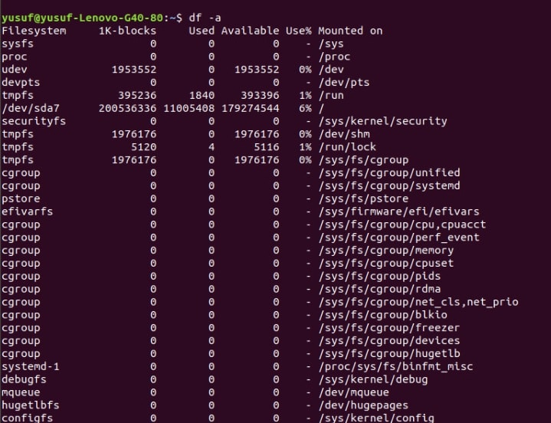

option :- df -hT --- It will display the information in human readable lang

2.**parted -l** :- create, re-organize the block , copy the disk data

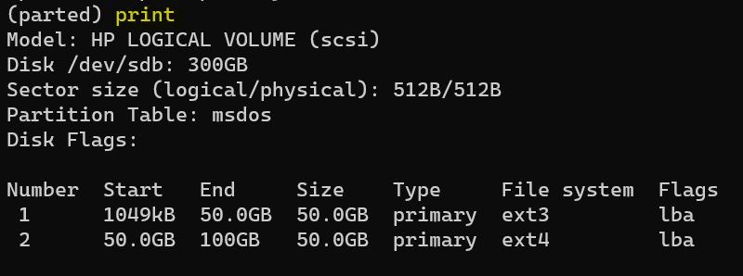

3.**fdisk -l** :create and manage disk partitions

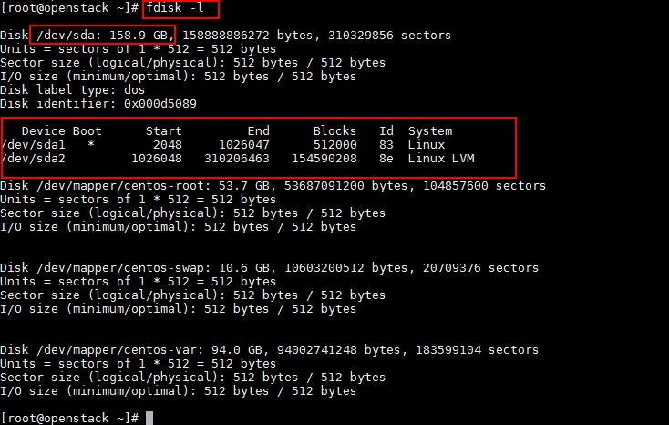

**4.lsblk** :- list block :- mounted block, devices, name, mountpoint

**5.blkid(block-id)** :- Block devices or paratition names, label, filessystem, UUID